Experiment – 5

Host Connectivity

Code :

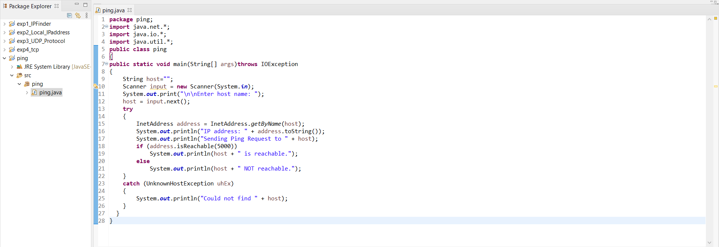

Output :

